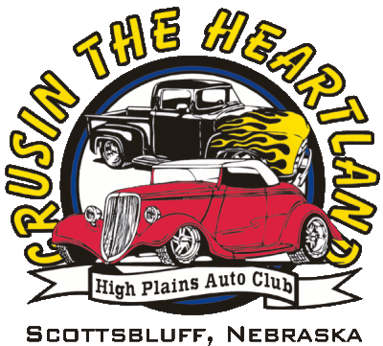
HIGH PLAINS AUTO CLUB
ROCK ‘N ROLL FATHER’S DAY CLASSIC
YOUR EARLY REGISTRATION IS APPRECIATED!

WELCOME TO GERING, NEBRASKA!

*****FRIDAY- June 15, 2018*****
BBQ MEAL / PARKING LOT PARTY FOR ENTRANTS ONLY
REGISTRATION OPEN @ 2:00 PM
Gering Civic Center - 1050 M St – Gering, NE 69341
CRUISE FOR CASH $$ AND ICE CREAM SOCIAL 6:00 P.M.– Entrants only
Pictures will be taken Friday and Saturday A.M. for our slide show presentation!

*****SATURDAY- June 16, 2018*****
DOWNTOWN GERING PARADE @ 9:00 A.M. TO FIVE ROCKS 8:30 A.M. LINE-UP N. 10th St
SHOW AND SHINE @ FIVE ROCKS AMPHITHEATER – 10 A.M. TO 4 P.M.
GRASS PARKING SITES - LUNCH VENDORS ON SITE-- DOOR PRIZES ALL DAY

*****SATURDAY NIGHT – June 16, 2018*****
AWARDS BANQUET – GERING CIVIC CENTER
Doors open at 5:00 P.M. Meal at 6:00 P.M.

CONTACT: Mike Reynolds 308-631-6573 - Daryl Wills 970-219-4087

Host Motel: Monument Inn & Suites 308-436-1950
Host Motel: Cobblestone to get discount call 308-633-7660
Scottsbluff / Gering, NE Area Hotels below – Robidoux RV Park 308-436-2046
Super 8 – Candlelight Inn – Comfort Inn – Hampton Inn
Arcadia Hotel – Barn Anew B & B – Lamplighter American Inn–Fairfield Inn

Eligible for Early Entry bonus drawing if entered by 3/1/17
Preregistered Entry fee $35.00 (2 people) – All Entries After June 1st $40.00
Each entry will receive 2 Friday BBQ meals and 2 Saturday Banquet meals.
– Limited extra meal tickets @ $15.00 each meal - Friday or Saturday Night
Mail entry forms ASAP to: High Plains Auto Club, P.O. Box 254, Scottsbluff, NE 69363-0254
e:mail: hpautoclub@gmail.com www.highplainsautoclub.com www.visitscottsbluff.com
Details subject to change as necessary / printed 01/2018

---CUT HERE - - - - - - - - - - - - - - - - - - - - - - - - - - - - - - - - - - - - - - - - - - - - - - - - - - - - - - - - - - - - - - - - - - - - - - CUT HERE ---
Name: _______________________________________________________Miles traveled one-way _________
Mailing address: ____________________________________________________________________________
City: ________________________State_______Zip Code: _______Phone:_____________Cell:____________
Club Affiliation______________________City: _______________State_____e-mail_____________________
Year: _________Make:_________________Model:___________________________Color: _______________
I understand that a reasonable effort will be made to protect my property, my family and me. Not every circumstance can be anticipated or prevented; therefore, I agree not to hold any member, official or sponsor of High Plains Auto Club/Rock ‘N Roll Father’s Day Classic liable for damage to my property, or injury to me or injury to any member of my family. Entrants hereby grant permission to HPAC to use their names, pictures, or pictures of their car for publicity, advertising and commercial purposes before, during and after the event and to relinquish rights to any photos taken in connection with the event.
ALL ENTRANTS MUST CARRY LIABILITY INSURANCE WITH MINIMUM LIMITS OF $25,000 – $50,000 – $25,000.

*SIGNATURE REQUIRED: _______________________________________(If under age 18 legal guardian must sign)

CLASSES: PLEASE CHOOSE THE CLASS THAT BEST DESCRIBES YOUR ENTRY:
Original Intent 1900–1950 |  |  | Original Intent 1951–1980 |  |  | Original Intent 1981–Current
Modified 1949–1980 |  |  | Modified 1981–Current |  |  | Trucks
Street Rods - must be Pre ‘49 |  |  | *Youth - Age Under 21 |  |  | HPAC Club Host Cars

* Youth Free with a valid Driver’s license, valid insurance and the car registration in their name. All other youth entries, normal charge $35.00.

