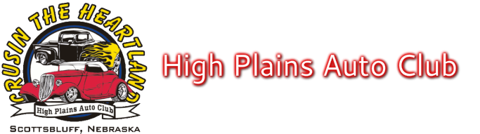

To Make Your Father’s Day Classic the Best Ever

- DOWNTOWN GERING PARADE @ 9:00 a.m. TO FIVE ROCKS: 8:00 a.m. LINE-UP on N. 10th St
If you want to park together at Five Rocks, please line up together in the parade.
- Vendors on site at Five Rocks, Saturday for Breakfast and Lunch
- No Dogs allowed. No Bicycles allowed.
- Voting ballots need to be turned in at registration table by 1:00 p.m. Saturday
- 2nd registered car is $10.00 (No Food Tickets)
- Extra Meal Tickets $15.00 for each meal, please pre-register so we don’t have to turn anyone away
- Please pick up registration packet and window card with number before getting car picture taken
- Gering city ordinance: No Candy can be thrown at parade
- Cars must be a registered and licensed vehicle
- “Cruise For Cash” is Free. Please register at Cruise for Cash table. Drawing at 6:00 p.m. Must be present to win.
- No Ice Cream allowed in the Civic Center
Please support our sponsors while you are in the area.
They make this car show possible.

Gold Sponsors
Scotts Bluff Area Visitors Bureau Riverstone Bank
KNEP-NBC Nebraska TV Logoz
Frank Parts Company High Plains Budweiser
The Meat Shoppe Masid Chevrolet
Rural Radio Network Wills Chiropractic Clinic P.C.
City of Gering Keno Funds Dooley Oil
Nemnich Automotive/Dyno Tuning/Storage Dairy Queen
Holyoke, Snyder, Longoria Reichert & Rice PC LLO - Attorneys at Law

Silver Sponsors
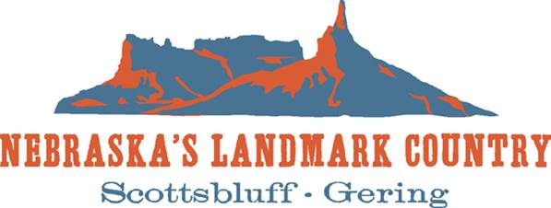
Loren’s Tractor Repair
Inland Truck Parts
Bumper to Bumper
Bill Weinmeister Livestock/ Bill & Jody Weinmeister

