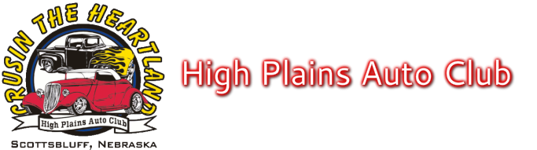

To Make Your Father’s Day Classic the Best Ever

- DOWNTOWN GERING PARADE @ 9:00 A.M. TO FIVE ROCKS 8:30 A.M. LINE-UP on N. 10th St
If you want to park together at Five Rocks, please line up together in parade.
- Vendors on site at Five Rocks, Saturday for Breakfast and Lunch
- No Dogs allowed
- Voting ballots need to be turned in at registration table by 1:00 p.m. Saturday
- 2nd registered car is $10.00 (No Food Tickets)
- Extra Meal Tickets $15.00 for each meal, Please pre-register so we don’t have to turn anyone away
- Please pick up registration packet and window card with number before getting car picture taken
- Gering city ordinance: No Candy can be thrown at parade
- Cars must be a registered and licensed vehicle
- “Cruise For Cash” is Free. Lots of prizes$$ Please register at Cruise for Cash table

Please support our sponsors while you are in the area.
They make this car show possible.

Sponsors
Scotts Bluff Area Visitors Bureau First State Bank
Greg's Auto Body & Paint Route 26 Mart
Frank Parts Company High Plains Budweiser
Lessert Insurance Masid Chevrolet
KNEB Radio 94.1 The Brand Wills Chiropractic Clinic P.C.
City of Gering Keno Funds Robinson Electric
Nemnich Automotive/Dyno Tuning/Storage The Meat Shoppe
Kelley Bean Co. Gary's Cleaning & Restoration Services
Culver's Restaurant KNEP-NBC Nebraska TV
Logoz
Chaloupka, Holyoke, Snyder, Chaloupka &, Longoria - Attorneys at Law

